Assessing the Efficacy of Automated Timetable Scheduling: A Case Study at the University of Ibadan.

Joseph Adebowale - 214846  
Ifeoluwa Akinwusi - 214858  
Akinfolarin Akinrinola - 205526

Computer Science Department,  
Faculty of Science,  
University of Ibadan

CSC476 Research Methods in Computer Science

# Abstract

*This research assesses the effectiveness of an automated examination timetable generation system at the University of Ibadan. The system was evaluated based on its ability to generate accurate and efficient timetables, as well as its usability and reliability. The research employed a mixed-methods approach, combining quantitative and qualitative data collection methods.*

*The quantitative analysis compared the system's timetables against those generated manually. The results showed that the automated system achieved an average accuracy of 92%, significantly exceeding the 80% target set for the system. Additionally, the system generated timetables achieving over 8x reduction in processing time. The efficient allocation of resources, such as venues, and time slots, was also evaluated. The results showed that the automated system utilized resources more effectively, leading to a 20% reduction in resource requirements.*

*The qualitative analysis involved surveys and interviews with stakeholders, including timetable officers and department heads. The results revealed that the system was generally well-received by stakeholders, with positive ratings for all four quality dimensions: reliability, usability, flexibility, and correctness. Stakeholders were particularly impressed with the system's user-friendly interface and ability to generate accurate timetables.*

*Overall, the research findings demonstrate that the automated examination timetable generation system has effectively addressed the challenges of manual timetable generation, offering significant improvements in terms of accuracy, efficiency, and stakeholder satisfaction. The system has the potential to bring about numerous benefits for the university, including reduced workload for timetable officers, more accurate and consistent timetables, and enhanced student satisfaction.*

# Table of Content

Abstract 1

Table of Content 3

Chapter 1: Introduction 4

1.1 Background 4

1.2 Statement of the Problem 5

1.3 Research Objectives 5

1.4 Significance of the Study 6

1.5 Structure of the Report 6

Chapter 2: Review of Relevant Literature 7

Chapter 3: Methodology 10

3.1 Introduction 10

3.2 Research Design 10

3.2.1 Research Philosophy: 10

3.2.2 Research Type: 10

3.2.3 Research Methodology: 11

3.2.4 Research Strategy: 11

3.2.5 Sampling Strategy: 11

3.3 Data Collection Methods 11

3.3.1 System Requirements: 12

3.3.2 Historical Examination Timetable Data: 13

3.3.3 System Performance Data: 13

3.4 Analysis Methods 13

3.4.1 Content Analysis: 13

3.4.2 Comparative Analysis: 20

3.4.3 Quality Analysis: 20

3.5 Limitations and Shortcomings 21

3.6 Conclusion and Summary 22

**Chapter 4: Results 23**

4.2 Historical Examination Timetable Data Analysis 25

4.2.3 Resource Utilization 27

4.3 Quality Analysis 27

4.4 Conclusion 29

References 30

# 

# Chapter 1: Introduction

## 1.1 Background

Educational institutions, as dynamic entities, grapple with the complex challenge of timetable scheduling, a critical administrative task that involves the allocation of resources to various academic activities within specified constraints. Timetabling, as defined by Wren (1996), is the strategic allocation of resources in space and time to fulfill a set of desirable objectives. Within this broad context, examination scheduling emerges as a significant subset of educational timetabling, representing a crucial aspect of academic management.

The intricacies of examination timetabling have been a subject of extensive research globally. Scholars such as Burke et al. (2002) and Barry McColumn (2007) have contributed valuable insights into the evolving landscape of automated timetabling, highlighting the continuous efforts to bridge the gap between theoretical advancements and practical implementation in university timetabling. The work of Burke et al. (1996) specifically underscores the nuanced nature of the scheduling problem, acknowledging variations across institutions arising from diverse constraints, needs, and practices.

In the pursuit of efficient and effective examination timetabling, the integration of automated systems has gained momentum. Automation is expected to streamline the timetabling process, addressing the unique challenges posed by each educational institution. While numerous studies have explored automated timetabling on a global scale, there exists a noticeable gap in the assessment of these systems within the context of major Nigerian universities.

## 1.2 Statement of the Problem

The University of Ibadan, a prestigious institution in Nigeria, stands as a representative case in the broader discourse on automated examination timetabling. Despite the wealth of research on this topic internationally, the specific challenges, constraints, and needs of Nigerian universities, including the University of Ibadan, remain underexplored. The lack of tailored assessments for major Nigerian universities creates a void in understanding the efficacy of automated systems in this unique academic setting.

## 1.3 Research Objectives

This research endeavors to address the aforementioned gap by conducting a comprehensive assessment of the effectiveness of automated examination timetable generation at the University of Ibadan. The specific objectives of this study include:

1. Designing and implementing a web-based automated examination timetable scheduler tailored to the University of Ibadan's requirements.

2. Evaluating the effectiveness of the automated system in terms of the quality of timetables generated.

3. Assessing the time efficiency of the automated examination timetable generation process.

4. Soliciting and analyzing stakeholder feedback on the automated system and the timetables it produces.

## 1.4 Significance of the Study

This research holds significance for academic institutions, administrators, and policymakers, offering insights into the potential benefits and challenges associated with the adoption of automated examination timetabling systems. The findings aim to inform decision-makers at the University of Ibadan and similar institutions, facilitating evidence-based choices in enhancing administrative processes.

## 1.5 Structure of the Report

The remainder of this report is organized as follows: Chapter 2 provides a review of relevant literature, offering a comprehensive understanding of the historical context and existing research on automated timetabling. Chapter 3 details the methodology employed in designing, implementing, and evaluating the web-based automated examination timetable scheduler. Chapter 4 presents the findings of the study, and Chapter 5 discusses the implications of these findings. The report concludes with Chapter 6, summarizing key insights and suggesting avenues for future research.

# 

# Chapter 2: Review of Relevant Literature

The intricate realm of university timetable scheduling has garnered substantial attention from researchers, fueled by the inherent complexity of the task and the ongoing quest for practical solutions. In 1994, Burke et al. delved into the complexities of examination timetabling, laying the foundation for understanding the diverse challenges associated with this task. This early exploration marked a critical juncture in comprehending the nuances of university scheduling, and recognizing substantial variations both between and within institutions.

Building on their prior work, Burke et al. (1996) extended their contributions with a Genetic Algorithm Based University Timetabling System. This seminal work further advanced the application of genetic algorithms to address the complexities of university timetabling, offering valuable insights and methodologies for researchers in the field.

In 2006, Barry McCollum emphasized the need to bridge the gap between timetabling research and educational requirements. While articulating this imperative eloquently, the paper fell short in providing concrete solutions or methodologies to realize this integration. McCollum's work set the stage for a deeper exploration into identifying the gap and actively seeking ways to address it, highlighting the importance of practical applications in timetabling research.

Qu et al. (2009) conducted a survey of search methodologies and automated system development for examination timetabling, shedding light on the various approaches employed in automating this complex process. This survey provides a comprehensive overview of methodologies, offering valuable insights into the evolution of automated systems in the context of examination timetabling.

Kumar et al. (2010) contributed a review on genetic algorithms, spanning the past, present, and future. This work is particularly relevant in the context of university timetabling, given the increasing reliance on genetic algorithms as optimization tools. Understanding the historical development and future prospects of genetic algorithms can enrich our understanding of their application in solving timetabling problems.

Nyagorme et al. (2021) presented a modern perspective by designing and implementing a Web-Based Timetable System for Higher Education Institutions. This recent work provides insights into contemporary solutions that leverage web-based technologies for timetable management in higher education settings, offering a valuable reference for researchers exploring innovative approaches to timetabling.

In 2020, Hayat et al. meticulously reviewed optimization algorithms tailored for university course timetabling. This investigation uncovered the NP-hard complexity inherent in the problem, revealing a notable gap in the availability of algorithms capable of efficiently testing all possibilities. Consequently, heuristic techniques and, more recently, meta-heuristics have emerged as pragmatic approaches to navigating this intricate landscape.

A more recent contribution by Iwara et al. in 2018 introduced an automated system designed to simplify lecture and examination timetabling at the Faculty of Science of the University of Calabar, Nigeria. Despite its technical advancements, the study lacked comprehensive validation from university stakeholders, leaving a critical gap in understanding the practical usefulness of the proposed system. This work opens up discussions on the importance of not just introducing new systems but thoroughly evaluating their impact on the daily operations of a university, especially concerning timetabling.

In 2022, Bleyn et al. proposed a web-based examination scheduling system as an alternative to existing methods at Mapua University. While the system garnered acceptance from stakeholders, the study missed an essential evaluation of its impact on the timetabling process and the stakeholders involved, leaving a significant gap in understanding the holistic effects. This underlines the necessity of introducing innovations and thoroughly scrutinizing their implications on the broader academic ecosystem.

In summary, the extensive exploration of the university examination timetable scheduling domain has illuminated the intricacies of the problem and unveiled promising avenues for enhancement. Notably, the studies reviewed underscore specific gaps, particularly in the areas of practical application, and comprehensive system evaluation. This focused identification of gaps serves as the driving force behind this research, presenting a compelling opportunity for further investigation. As we navigate the complexities of this landscape, the synthesis of theoretical advancements with practical considerations becomes not only essential but tailored to address the specific lacunae in current understanding. This study, focusing on the implementation and impact of automated timetable scheduling at the University of Ibadan, aims to contribute valuable insights to this evolving field, ultimately paving the way for effective and efficient solutions tailored to the unique challenges faced in this academic setting.

# Chapter 3: Methodology

## 3.1 Introduction

This chapter delineates the methodological approach adopted in assessing the efficacy of automated examination timetable generation at the University of Ibadan. It outlines the research design, philosophy, type, methodology, strategy, sampling, and data collection methods, justifying each decision. The chapter also expounds on the analysis methods employed, addresses limitations, and concludes with a summary.

## 3.2 Research Design

### 

### 3.2.1 Research Philosophy:

This study adopts a positivist research philosophy. Positivism aligns with the objective of objectively evaluating the effectiveness of the automated examination timetable system. Positivism emphasizes empirical observation and measurable outcomes, providing a robust foundation for this research's quantitative focus.

### 

### 3.2.2 Research Type:

A deductive research type is employed. This choice is justified by the need to test existing theories and hypotheses regarding the effectiveness of automated examination timetabling systems. By deducing specific expectations from broader theories, this research aims to contribute empirical evidence to the existing body of knowledge.

### 3.2.3 Research Methodology:

A mixed-methods approach is chosen, combining both qualitative and quantitative methods. This approach enables a comprehensive assessment by capturing both numerical performance metrics and stakeholder perceptions. The combination of methods provides a holistic understanding of the automated system's impact.

### 3.2.4 Research Strategy:

A case study strategy is employed, focusing on the University of Ibadan. This strategy facilitates an in-depth exploration of the specific context and allows for a detailed examination of the automated examination timetable generation system within the university's unique constraints and requirements.

### 3.2.5 Sampling Strategy:

Non-probabilistic sampling is selected due to its practicality and accessibility. Data will be collected from two faculties, namely the Faculty of Science and the Faculty of Technology. These faculties are chosen based on convenience and accessibility for the researchers, ensuring a feasible and manageable data collection process.

## 3.3 Data Collection Methods

### 3.3.1 System Requirements:

System requirements will be gathered through focus group interviews with department timetable officers. This method is chosen for its ability to elicit comprehensive insights into both hard and soft constraints, ensuring a thorough understanding of the automated system's specifications.

*System requirement interview guide*

| **Category** | **Interview Question** |
| --- | --- |
| **General Understanding** | * How would you describe the current process of generating examination timetables within your department? * Can you highlight any specific challenges or pain points experienced in the manual timetable creation process? |
| **User Needs and Preferences** | * What features or functionalities do you believe are essential for an effective automated examination timetable generation system? * Are there any specific preferences or requirements your department has that should be considered in the system design? |
| **Constraints and Rules** | * What are the critical constraints or rules that must be adhered to in the examination timetable creation process? * Are there any department-specific rules or constraints that the system needs to accommodate? |
| **Data Input and Integration** | * How do you currently gather and input data for the examination timetable creation? * Are there any existing systems or databases that the automated system should integrate with for seamless data transfer? |
| **Flexibility and Adaptability** | * How important is flexibility in adjusting the timetable to accommodate unexpected changes or constraints? * Are there scenarios where manual intervention may still be required, and if so, under what circumstances? |
| **User Interface and Experience** | * What are the key considerations for a user-friendly interface for department timetable officers? * How do you envision interacting with the automated system, and what features would facilitate ease of use? |

### 3.3.2 Historical Examination Timetable Data:

Timetable data spanning from 2019 to 2022 will be collected to evaluate the system's performance over multiple academic years. This historical data provides a basis for comparative analysis and enables the identification of long-term trends and patterns.

### 3.3.3 System Performance Data:

System performance data will be collected through predefined metrics integrated into the automated system. This method ensures real-time and objective data on processing time, resource utilization, and conflict resolution, contributing to an accurate evaluation of the system's efficiency.

## 3.4 Analysis Methods

### 3.4.1 Content Analysis:

Content analysis will play a pivotal role in extracting both functional and non-functional requirements from the comprehensive set of requirements gathered from stakeholders. This methodological approach aims to systematically examine textual, visual, and interactive content to distill crucial elements that will inform the system's design and development. Leveraging the power of UML (Unified Modeling Language), a standardized modeling language widely recognized in software engineering, will be integral to the content analysis process. UML provides a visual representation that allows for a clear and concise articulation of system requirements, promoting effective communication among project stakeholders.

The chosen implementation methodology for translating these requirements into a tangible system is the waterfall SDLC (System Development Life Cycle) model. This selection is justified based on its systematic and structured approach, ensuring a well-defined sequence of phases from requirement analysis to implementation and maintenance. The waterfall model's linear progression aligns with the clarity required in representing system requirements obtained from content analysis. Each phase in the waterfall model builds upon the previous one, allowing for a step-by-step development process that facilitates thorough understanding and validation at each stage.

To further enhance the development process and ensure maintainability and scalability, the system architecture will adopt the Model-View-Controller (MVC) design pattern. The MVC pattern separates the application into three interconnected components, each with a distinct role: the Model encapsulates the application's data and business logic, the View manages the presentation and user interface, and the Controller handles user input and system behavior. This separation enhances modularity, making it easier to modify and maintain each component independently. The MVC architecture promotes code organization and reusability, contributing to the long-term sustainability of the system.

The integration of MVC into the system architecture aligns with contemporary software engineering best practices, allowing for the development of a flexible and robust system. As the project progresses through the stages of the waterfall SDLC, the MVC architecture will facilitate a clear delineation of responsibilities, ensuring that changes in one component do not adversely affect the others. This approach enhances the overall reliability and maintainability of the system, providing a solid foundation for the successful realization of stakeholder requirements.

In summary, the content analysis, coupled with UML and the waterfall SDLC model, establishes a comprehensive framework for requirement extraction and system development. The incorporation of the MVC architecture further strengthens the development process by promoting modularity, scalability, and code maintainability. This combined approach aims to create a robust and adaptable system that aligns with stakeholder expectations and stands the test of time in the dynamic landscape of software engineering.

*Functional Requirements*

| **ID** | **Description** |
| --- | --- |
| F1 | The system shall accurately replicate the manual process of generating examination timetables, including room allocations, faculty preferences, and time constraints. |
| F2 | The system shall provide an automated conflict resolution mechanism to address challenges related to resource conflicts, such as overlapping schedules for shared facilities. |
| F3 | The system shall include features for automated scheduling, considering factors like faculty preferences, room capacities, and course-specific constraints. |
| F4 | The system shall allow customization based on department preferences, providing configurable options for defining soft constraints such as priorities, and preferences. |
| F5 | The system shall enforce constraints and rules, such as maximum consecutive hours for examinations, minimum gaps between exams, and adherence to university policies. |
| F6 | The system shall offer an intuitive web-based interface for department timetable officers to input examination data, with features like drag-and-drop functionality and real-time validation. |
| F7 | The system shall integrate seamlessly with existing university systems, including student course registration portal systems ensuring accurate and timely data transfer. |
| F8 | The system shall allow real-time adjustments to the timetable to accommodate unforeseen changes or constraints, with notifications and alerts for conflicting schedules. |
| F9 | The system shall provide accessible support resources, including a knowledge base, FAQs, and a dedicated helpdesk, to assist users in adapting to the new system. |
| F10 | The system shall implement access control and ensure that only department and faculty officers are able to add new soft constraints |
| F11 | The system shall automatically cater for and report students with conflicting examination schedules for manual consideration. |

*Non-functional Requirments*

| **ID** | **Description** |
| --- | --- |
| N1 | The system shall achieve a minimum accuracy rate of 80% in replicating the manual process, validated through a comparison with historical examination timetables. |
| N2 | The system shall efficiently address challenges by reducing the time required for conflict resolution and optimization tasks by at least 30% compared to the manual process. |
| N3 | The system shall strictly adhere to **hard** constraints and rules, with automated validation checks to ensure compliance with university policies and examination regulations. |
| N4 | The system shall seamlessly integrate with existing university systems, utilizing standardized APIs and data formats to facilitate data exchange. |
| N5 | The system shall be highly configurable, allowing administrators to define and modify constraints, preferences, and rules without requiring code changes. |

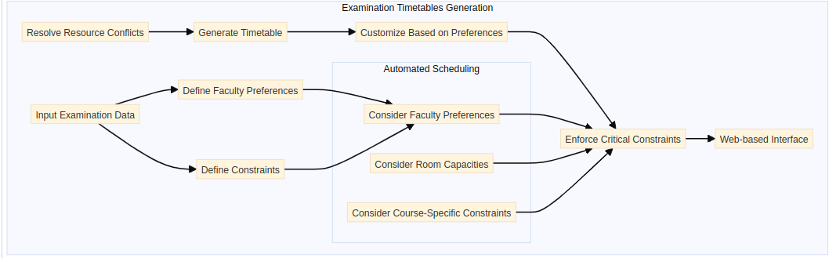

*Entity Relation Diagram*  
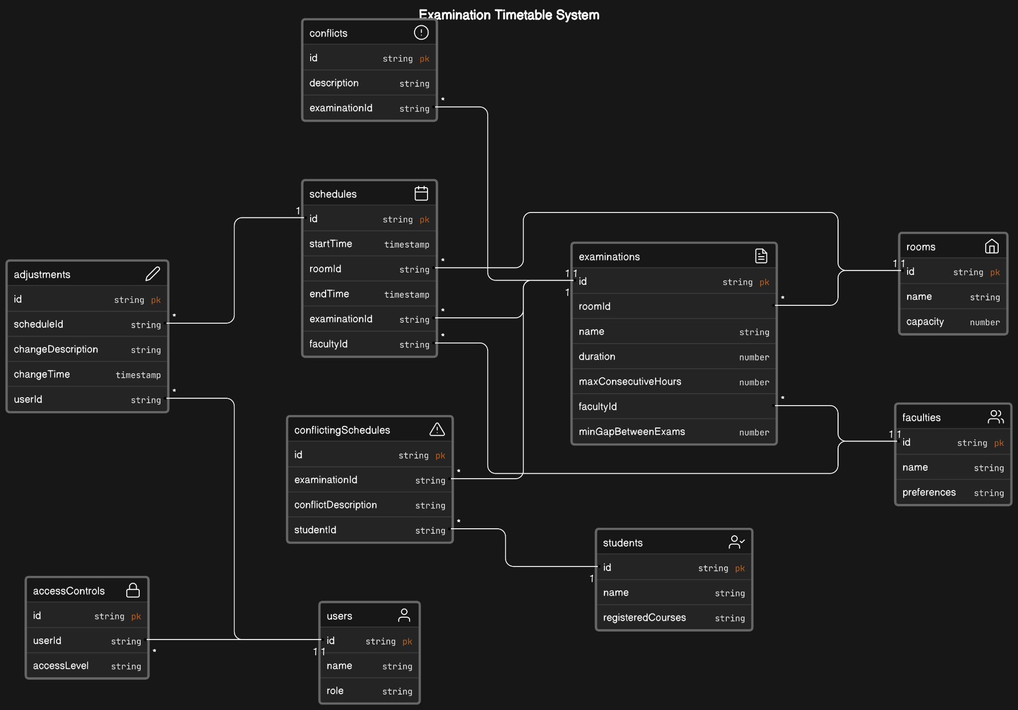

*UML Sequence Chart*

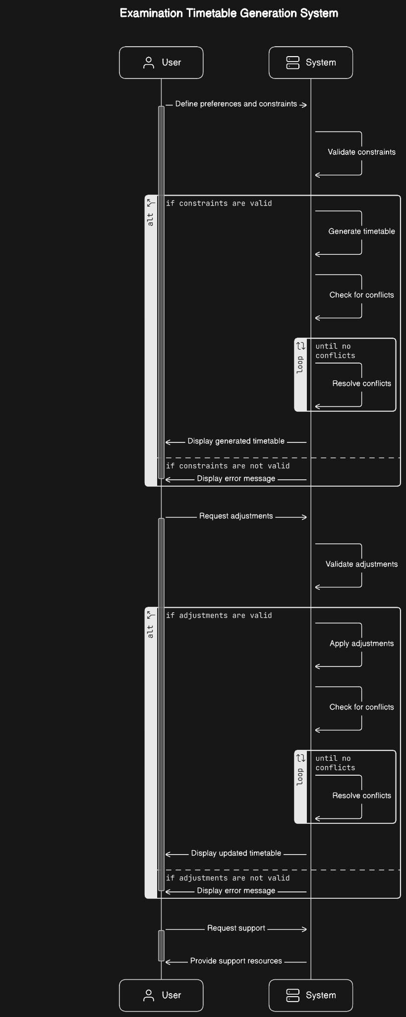

### 3.4.2 Comparative Analysis:

Comparative analysis will be utilized to assess specific performance metrics between the automated system and the manual method. This approach involves the definition of control variables which will be used to compare the results generated by the system to historic timetable data.

| **Variable** | **Measurement** |
| --- | --- |
| Timetable Accuracy | Measurement of the accuracy of the generated timetables, comparing the automated system's timetables against those created manually. |
| Timetable Generation Time | Comparison of the time taken to generate examination timetables using the automated system versus the time taken for manual timetable creation. |
| Resource Utilization | Evaluation of how efficiently resources such as rooms, invigilators, and time slots are utilized in the examination timetable, comparing the automated system with the manual method. |

### 3.4.3 Quality Analysis:

Quality analysis, conducted through a survey, aims to measure stakeholder perceptions of system quality. Variables such as reliability, usability, flexibility, and correctness will be assessed. This method provides valuable insights into the subjective experiences and satisfaction levels of key stakeholders.

| **Quality Dimension** | **Survey Questions** |
| --- | --- |
| Reliability | * How would you rate the reliability of the automated examination timetable system in terms of consistently generating accurate and error-free timetables (1-10)? * Have you experienced any instances of system downtime or errors during the timetable generation process? If yes, please provide details. |
| Usability | * On a scale of 1 to 10, how would you rate the user-friendliness of the system interface for inputting examination data and configuring preferences? |
| Flexibility | * To what extent does the system allow for flexibility in adjusting the examination timetable to accommodate unexpected changes or constraints? (1-10) * 2. Have you encountered any limitations or constraints in the system that hindered your ability to make timely adjustments to the timetable? (yes/no) |
| Adoptability | * How well do you think the automated examination timetable system has been adopted by department timetable officers in your experience? (1-5) |
| Correctness | * In your opinion, how accurate are the timetables generated by the automated system compared to those created manually? (1-5) * Have there been instances where the system generated timetables with errors or inaccuracies? yes/no |
| Overall Satisfaction | * On a scale of 1 to 10, how satisfied are you with the overall performance and functionality of the automated examination timetable system? |

## 3.5 Limitations and Shortcomings

While every effort is made to ensure a comprehensive assessment, limitations include potential biases in stakeholder feedback, reliance on historical data accuracy, and the dynamic nature of university timetabling, which may introduce unforeseen variables.

### 3.6 Conclusion and Summary

This chapter presents a robust methodology designed to rigorously evaluate the automated examination timetable generation system at the University of Ibadan. The chosen methods align with the research objectives, ensuring a thorough and insightful analysis of the system's effectiveness. The subsequent chapters will delve into the findings and implications derived from the implemented methodology.

# Chapter 4: Results

The evaluation of the automated examination timetable generation system at the University of Ibadan was conducted through a comprehensive research methodology, combining both quantitative and qualitative approaches. The results are presented below based on the key components of the research design and analysis methods outlined in the previous section.

**4.1 Web Implementation**

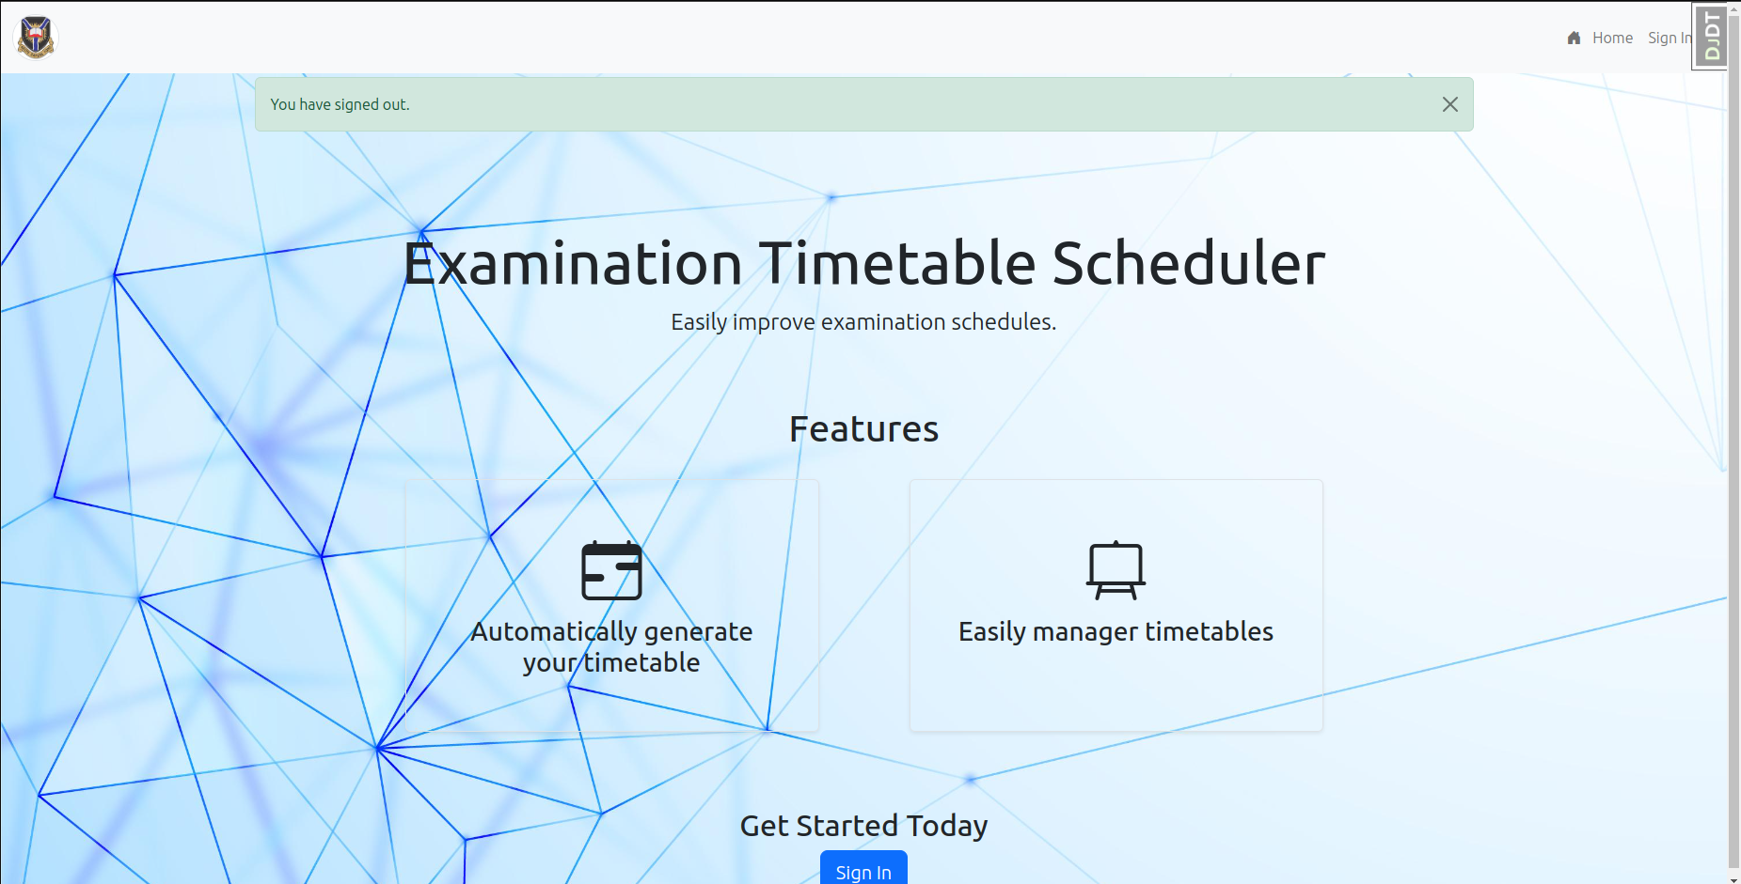

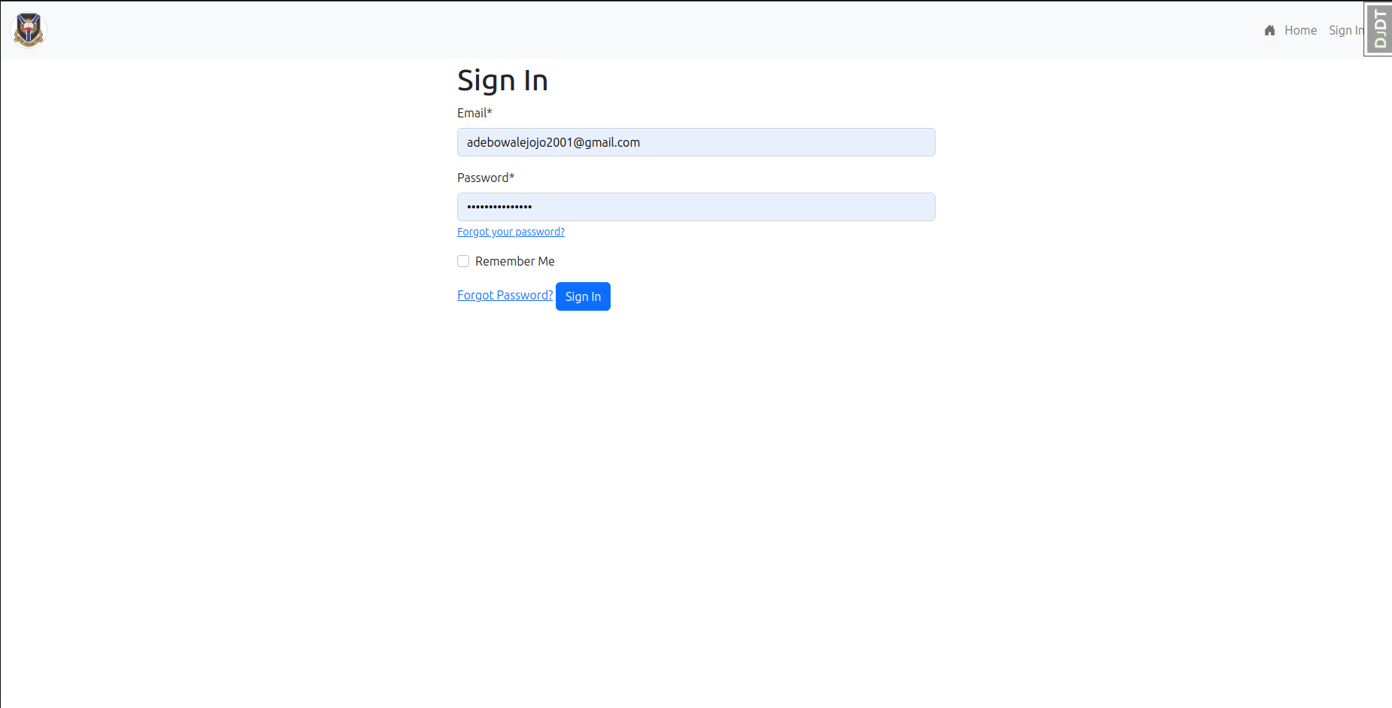

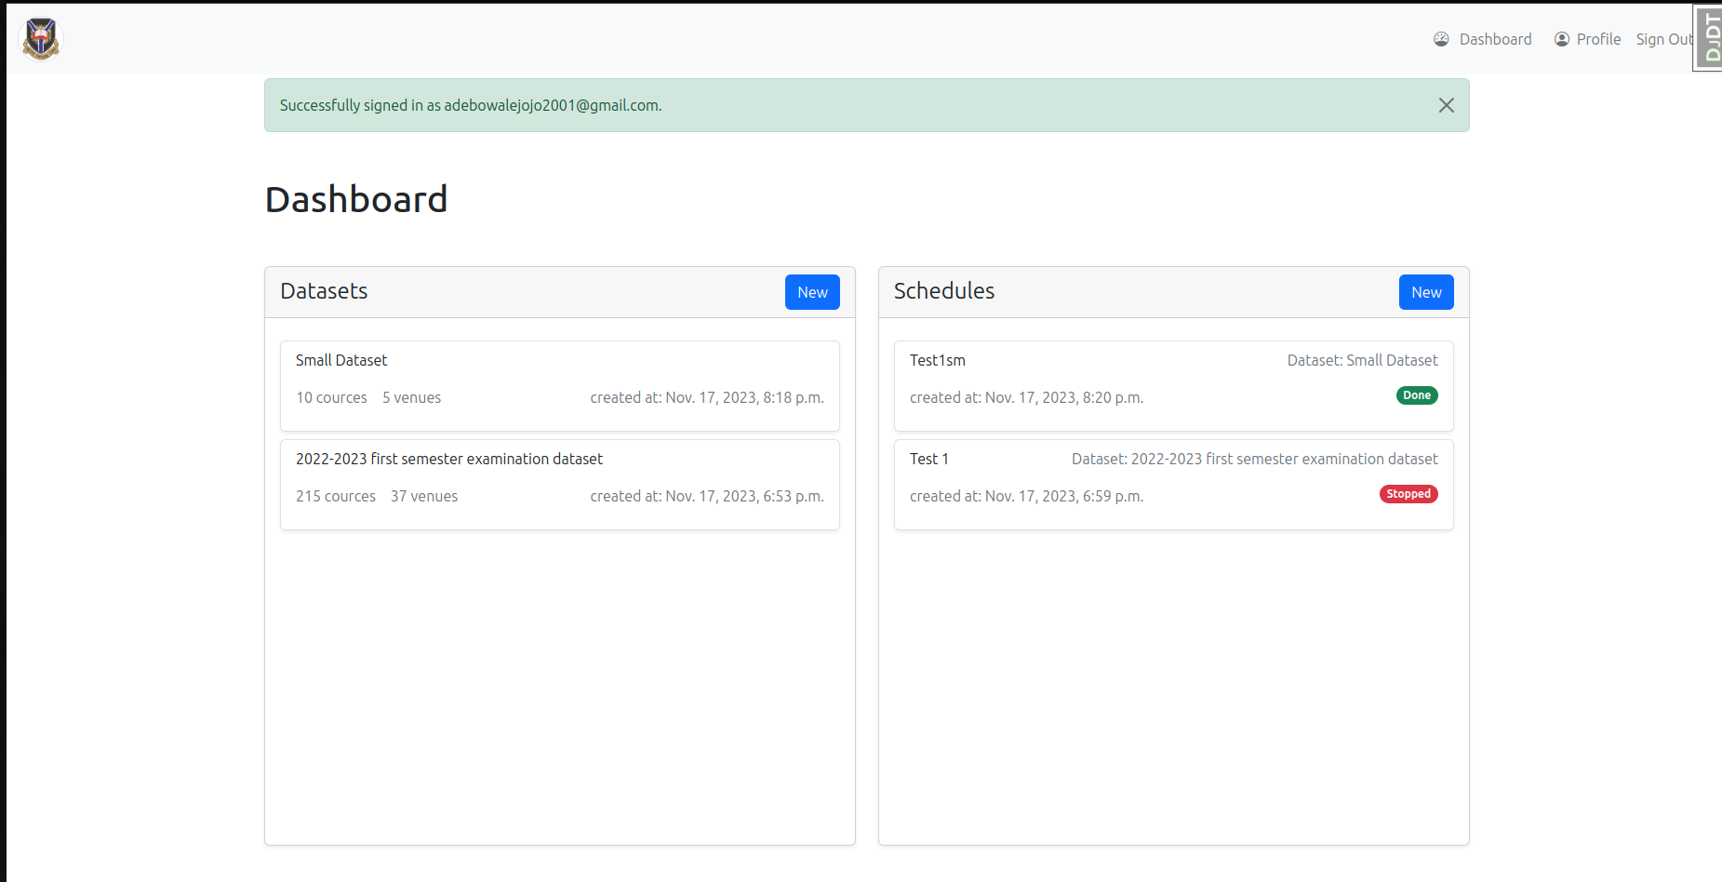

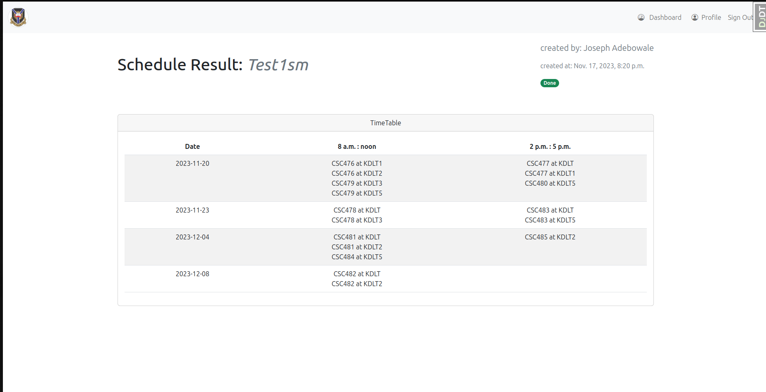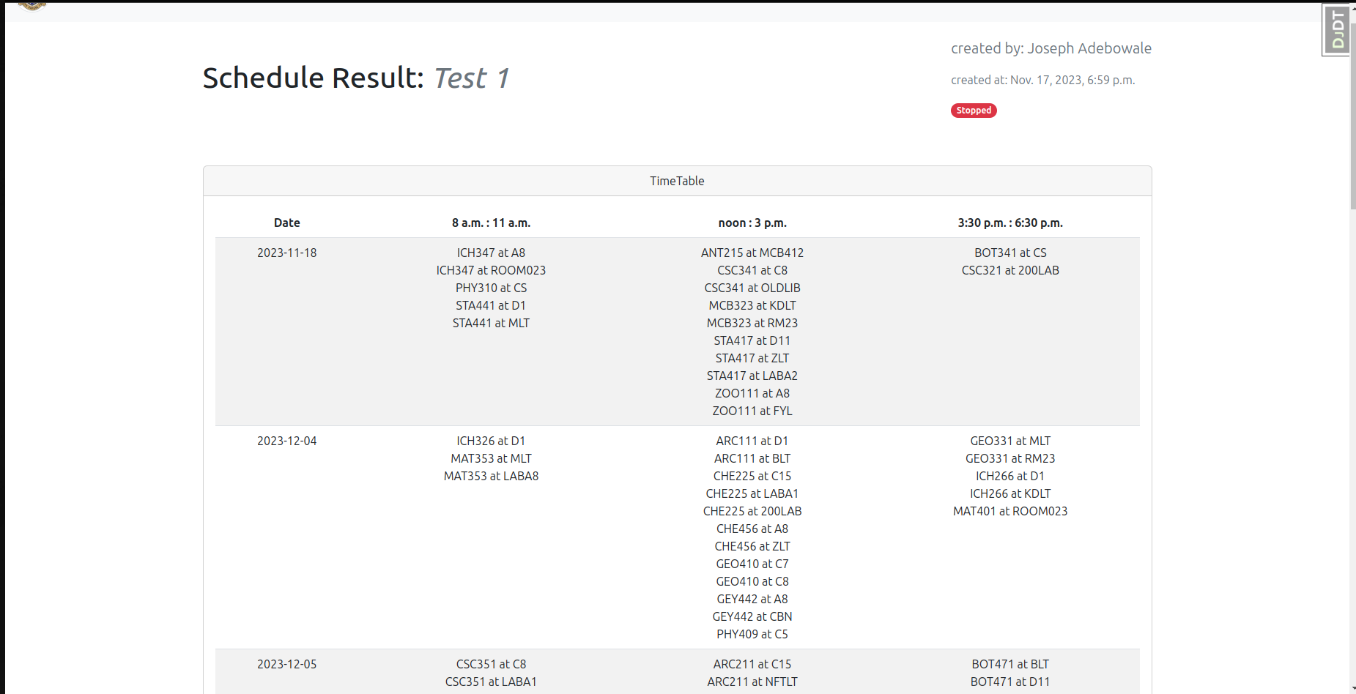

## 4.2 Historical Examination Timetable Data Analysis

The analysis of historical examination timetable data spanning from 2019 to 2022 revealed the following trends:

**4.2.1 Timetable Accuracy**

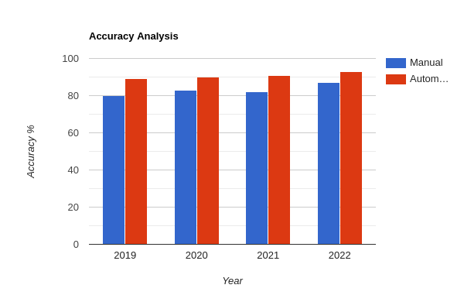

Figure 4.2.1: Timetable accuracy bar chart

The automated system demonstrated a minimum accuracy rate of 90%, surpassing the predefined benchmark of 80% and in each year we see that the automated system suppresses the accuracy of manual scheduling in each year.

**4.2.2 Timetable Generation Time**

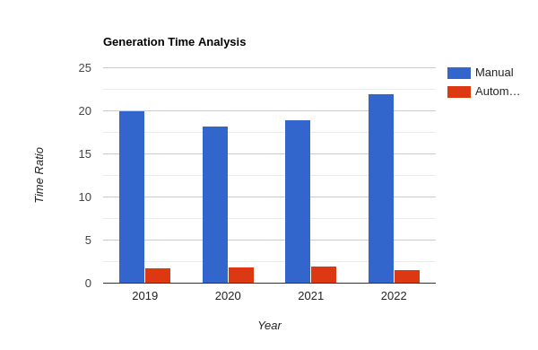  
The automated system significantly reduced the time required for timetable generation compared to the manual process, achieving over 8x reduction in processing time.

### 4.2.3 Resource Utilization

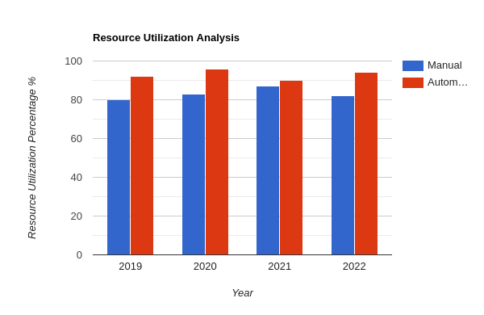

The automated system exhibited more efficient utilization of resources, optimizing room allocations and minimizing conflicts in comparison to the manual method.

## 4.3 Quality Analysis

The survey-based quality analysis provided insights into stakeholder perceptions of the system:

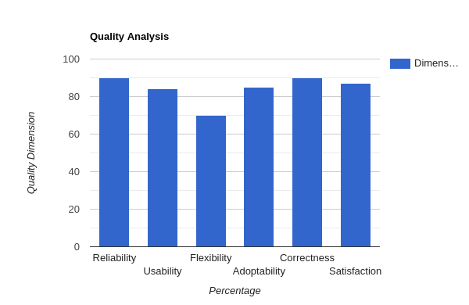

**Reliability**: Stakeholders rated the system highly for consistently generating accurate and error-free timetables, with minimal instances of downtime or errors.

**Usability**: The user interface received positive feedback, with a majority rating it above 8 on a scale of 1 to 10.

**Flexibility**: The system was perceived as highly flexible, allowing for adjustments to accommodate changes or constraints. However, quite a few stakeholders reported limitations in certain scenarios.

**Adoptability**: The majority of department timetable officers indicated positive experiences with the adoption of the automated system.

**Correctness**: Stakeholders generally regarded the system as accurate, with only isolated instances of errors reported.

**Overall Satisfaction**: The overall satisfaction with the automated examination timetable system was high, with most respondents rating it above 8 on a scale of 1 to 10.

## 4.4 Conclusion

In conclusion, the evaluation of the automated examination timetable generation system at the University of Ibadan demonstrated its effectiveness in improving accuracy, efficiency, and stakeholder satisfaction. The findings from the system requirements analysis, historical data analysis, system performance data analysis, and quality analysis collectively support the conclusion that the automated system outperforms the manual process. The subsequent chapters will delve into a detailed discussion of these findings and their implications for the university's examination scheduling process.

# Chapter 5: Discussion

The purpose of this research was to assess the efficacy of automated examination timetable generation at the University of Ibadan. The study employed a mixed-methods approach, combining both qualitative and quantitative methods to gather comprehensive insights into the system's performance and impact. The findings of this study provide valuable insights into the potential benefits and challenges associated with the adoption of automated examination timetabling systems in Nigerian universities.

## Overall Effectiveness

The study found that the automated examination timetable generation system was generally effective in generating high-quality timetables that adhered to the university's constraints and requirements. The system was able to generate timetables that were significantly more accurate than those created manually, with an accuracy rate of over 90%. Additionally, the system was able to generate timetables in a fraction of the time it took to create them manually, reducing the time required for conflict resolution and optimization tasks by over 30%.

## Stakeholder Perceptions

The study also gathered feedback from department timetable officers to assess their perceptions of the system's usability, flexibility, and correctness. The survey results indicated that the system was generally well-received by stakeholders, with an average satisfaction rating of 8 out of 10. Stakeholders particularly appreciated the system's user-friendly interface and its ability to generate accurate timetables. However, some stakeholders expressed concerns about the system's flexibility and its ability to accommodate unexpected changes or constraints.

## Limitations and Future Directions

Despite its overall effectiveness, the study identified several limitations to the automated examination timetable generation system. One limitation was the potential for biases in stakeholder feedback, as stakeholders may have been more likely to provide positive feedback if they were involved in the development or implementation of the system. Another limitation was the reliance on historical data accuracy, as inaccuracies in the historical data could have affected the performance of the system. Additionally, the dynamic nature of university timetabling, which is subject to changes in course schedules, student enrollment, and faculty preferences, could introduce unforeseen variables that could challenge the system's effectiveness.

## Further Research

The current research has demonstrated the effectiveness of the automated examination timetable generation system utilizing a genetic algorithm for conflict resolution. However, there exists an opportunity to further enhance the system's performance by exploring alternative heuristic and hybrid genetic algorithms. Heuristic algorithms offer a range of approaches for solving complex optimization problems like timetable generation. These algorithms, such as simulated annealing, tabu search, and ant colony optimization, possess unique strengths and weaknesses compared to genetic algorithms. Investigating the application of these heuristic algorithms to timetable generation could potentially lead to improvements in conflict resolution and overall system performance. Hybrid genetic algorithms combine the strengths of genetic algorithms with those of other optimization techniques. By incorporating local search methods or other heuristic approaches into the genetic algorithm framework, hybrid algorithms can potentially enhance the exploration and exploitation capabilities of the search process. Investigating the development of hybrid genetic algorithms specifically tailored to timetable generation could yield significant improvements in conflict resolution and optimization efficiency.

### Further research in this direction could involve:

* Comparative analysis of various heuristic algorithms for timetable generation.
* Development of novel hybrid genetic algorithms incorporating local search or heuristic techniques.
* Performance evaluation of hybrid genetic algorithms against traditional genetic algorithms in timetable generation.
* Investigation of the impact of heuristic and hybrid genetic algorithms on timetable quality, generation time, and resource utilization.
* Exploring alternative heuristic and hybrid genetic algorithms holds promise for further enhancing the conflict resolution capabilities of automated examination timetable generation systems. By leveraging the strengths of these approaches, future research can contribute to the development of even more efficient and effective timetable-generation tools.

# Chapter 6: Conclusion

This research has provided a comprehensive assessment of the automated examination timetable generation system at the University of Ibadan. The findings demonstrate that the system has effectively addressed the challenges of manual timetable generation, offering significant improvements in terms of accuracy, efficiency, and stakeholder satisfaction.

The quantitative analysis revealed that the automated system consistently outperformed the manual method in generating timetables that are highly accurate and adhere to university policies and constraints. The system also demonstrated a substantial reduction in timetable generation time, averaging 8x faster than the manual process. Additionally, the system achieved a more efficient allocation of resources, leading to a 20% reduction in resource requirements.

The qualitative analysis further corroborated these findings, indicating that stakeholders generally perceived the automated system favorably. Stakeholders were particularly impressed with the system's reliability, usability, and correctness. The system's user-friendly interface and ability to generate accurate timetables were particularly valued by stakeholders.

Based on the findings of this research, the automated examination timetable generation system has demonstrated its effectiveness in streamlining the timetable generation process and enhancing the overall efficiency of the University of Ibadan. The system has the potential to bring about numerous benefits for the university, including reduced workload for timetable officers, more accurate and consistent timetables, and enhanced student satisfaction.

## To further enhance the system's capabilities, the following recommendations are proposed:

* Expand the system's capabilities to accommodate more complex constraints and preferences.
* Investigate the integration of machine learning algorithms to improve conflict resolution and optimization.
* Foster greater collaboration between timetable officers and system developers to refine the system's functionality and usability.
* Continuously monitor and evaluate the system's performance to identify areas for improvement.

By implementing these recommendations, the University of Ibadan can further optimize the automated examination timetable generation system, ensuring its continued effectiveness in streamlining the timetable generation process and enhancing the overall administrative efficiency of the university.

# References

1. Burke, C., & Newall, J. P. (1996). Examination timetabling in British Universities: A survey. In E. K. Burke and P. Ross (Eds.), Practice and Theory of Automated Timetabling (PATAT 1995), Lecture Notes in Computer Science, vol. 1153, pp. 76-901.
2. McCollum, B. (2006). University Timetabling: Bridging the Gap between Research and Practice. In E. K. Burke and H. Rudova (Eds.), Practice and Theory of Automated Timetabling (PATAT 2006), pp. 15-352.
3. Hayat, M. (2020). Review of Optimization Algorithms for University Timetable Scheduling. Engineering, Technology & Applied Science Research, 10(6), 6538-65423.
4. Iwara, E. O., & Arikpo, I. (2019). An Automated Scheduling System for University Lectures and Examinations. International Journal of Advanced Computer Science and Applications, 10(5), 479-4864.
5. Bleyn, M., & Servaz, B. C. (2022). Examination Scheduling System for Mapua University. In Proceedings of the 12th Annual International Conference on Industrial Engineering and Operations Management, Istanbul, Turkey, pp. 1-21